NAME: - RAJESH KUMAR JHA
MOBILE NO:-+91-9582984203
E-MAIL ID:-kumarrajesh.raja@gmail.com
ADDRESS FOR CORRESPONDENCE

ADDRESS FOR CORRESPONDENCE

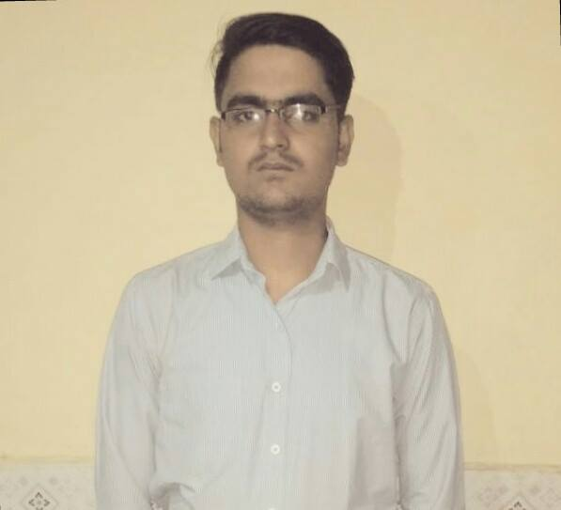

S/O RAMESH JHA, AT- KHAMGARA, P.O- JAMUA,
DIST- ARARIA (BIHAR) PIN. NO- 854331.

OBJECTIVE

To be an astute learner and utilizing my capabilities to its optimum strength in your organization. So that I can build an innovative career in your esteemed organization by using my skills.
ACCADEMIC ENRICHMENT

B-Tech from ABIT(Cuttack) in Discipline Electrical and Electronics Engineering With CGPA 6.8
12th (+2 Science) from R.K.C.K College at Araria in the year 2009 with an aggregate of 77.2%.
10th from Moti High School at Madanpur Araria in the year 2007 with an aggregate of 58%.
EXPERIENCE

Three months of experience at Medhaj Techno Concept Pvt. Ltd. As a site engineer as well as 2 year 5 months work experience as Sr. Executive/ Team Leader/Supervisor in Quality control Department at Naaptol Online Shopping pvt. Ltd. from 13th august 2015 to till date.

ACHIVEMENT

I have got star of the year performance awards from Naaptol online shopping pvt. Ltd.

TITLE:-Summer Training ORGANIZATION:-PATRATU THERMAL POWER STATION, RAMGARH
TRAINING & PROJECTS
DURATION:-15 days
Brief Description:- I have successfully completed my training, covering topics like Coal Power Generating System of Patratu of PTPS.
PROJECT 1:-Water Level Detector
DESCRIPTION:-This is the minor-project which i have done successfully. This is used to detect the level of water and it is alert of wasting of water when water of fill in the last level then it is automatically the alarm start buzzing.
PROJECT2:- Home Automation Based Remote Control
DESCRIPTION: - This is a major project which I have done successfully. This is a remote sensing control on home automation using Microcontroller.
WORKSHOPS AND SEMINARS

NAME:-workshop on ROBOTICS
DESCRIPTION: - I have attended a workshop in the first year of B.tech which was organized by IIT KHARAGPUR in year 2011.

NAME:-Seminar held by ISTE Odisha
DESCRIPTION:-I have attended the seminar of ISTE National seminar on Technical Education in India.
NAME:-Isolation Transformer
DESCRIPTION: - This is the presentation which I have given in our seminar paper. This paper deals with the advantage over normal transformer like it is more safe to operate in severe condition and it also produce less noise so that noise pollution is being reduced. It has also better power quality compare to normal transformer.

AVOCATIONS

- Web Surfing, participate college sport club(cricket)

- Accessing Social Networking sites
STRENGTH
- Objective oriented and highly motivated

- Excellent analytical and problem solving skills

- Highly energetic and dedicated
PERSONAL DETAILS

Date of Birth:-20th December 1991
Gender: - Male
Marital Status: - Unmarried
Nationality: - Indian
Blood Group: - B+
Language Proficiency: - English, Hindi.
Favorite Subjects:- Electrical Machine
DECLARATION

DECLARATION

I hereby declare that the above mentioned information is correct up to my knowledge and I bear the responsibility for the correctness of the above mentioned particulars.

Date: (Signature)
Place: ----------------------------

